**How to use MUI icons (Material UI) in React**

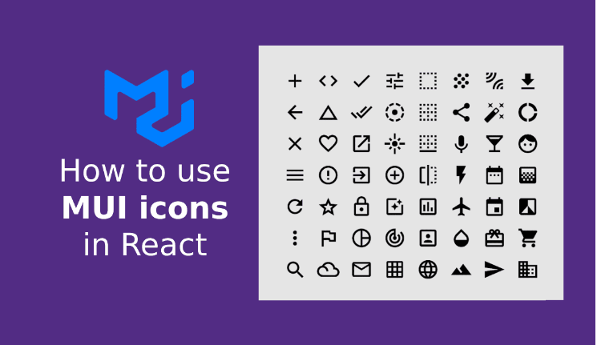

Following on from my post about changing the Material UI Appbar background color, this is a tutorial on using Material UI Icons (MUI icons) in a React app. I describe how to change the MUI icon size and color, and how to add a hover style. Before we dive into the detail I’m presuming that you’ve created a React app already, so once you are ready to start focusing on using Mui icons in your Material UI React app you’ll need to install Material UI for React, and install Material UI icons (material-ui/icons), both of which I’ll discuss below.

## **Install Material UI for React:**

For this tutorial I’ll be using Mui, a component library for React using Material UI.

Use the following command to install the latest package to your React app, I’ll be using MUI v5.2.7 which is the newest version at the time of writing this post:

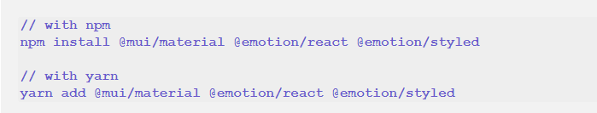

# Install Roboto font:

As per the documentation, Mui was designed with Roboto font in mind, but it isn’t installed automatically, so we need to do that now. There are several different ways of doing this but I’ll import it from a CDN for this tutorial. Add this to your index.html file above the Title tag:

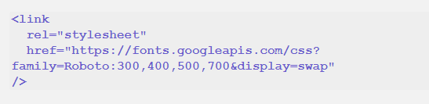

## **Install a Material UI Icons package:**

I’ve said ‘a material UI icons package’ because there isn’t just 1, there are 3 different ways of using icons with Material UI. You can use any icon font, or SVG icon with material UI, but I’m going to explain how to use React Material icons library. It’s a library of 1300 icons made specifically to use with Material UI.

In order to use this package, you need to install the Material UI npm package. Again, follow their instructions for the most up to date command, but you’ll need to use a command like this to install the package:

# 

## **View and use Mui icons:**

You can view the whole @mui/icons-material library of icons online. Once you’ve found the icon(s) you want to use, make a note of the name. You can search for icons, so let’s say you’re looking for an icon to do with a beach, you’d search here:

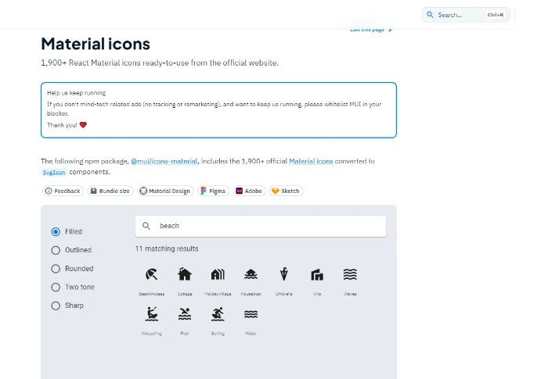

### **Import each Material UI icon:**

You can import each icon individually by using its name, and in VS Code, as you start typing the name within the curly brackets, you’ll see an autocomplete list come up of all of the available icons. So importing the BathroomICon icon would look like this:



### **Show the Mui icon on the page:**

Once you’ve imported the icon or icons that you need you’re ready to add them to the correct position in your page. To show the Bathroom Icon in the page you’d simply reference it like this:



That’s the simplest example of how to use an icon in React using Material UI. It’s likely though that you’ll want to change the icon somehow. In Material UI each icon also has a ‘theme’, so most of the icons have variations as follows:

* Filled (default)
* Outlined
* Rounded
* Two-tone
* Sharp

To import the Mui Material icon component with a theme other than the default, use this code in your App.js file:

